LECTURE 3.3.2
TREES
Course outcome to be covered:
CO4: Apply and recognized about the Trees

  - TYPES OF TREES AND THEIR IDENTITIES
In this lecture we will describe different types of trees, their basic properties and examples. To understand the concept of trees it is essential to know various common types of trees.
  - TOPIC OBJECTIVES
- The students will be able to know different types of trees such as ordered tree, rooted tree, binary tree etc. which are very useful.
- The different properties for the trees will be clear after this lecture.
1.3 STRUCTURE:
- Introduction
- Types of trees
- Ordered trees
- Rooted trees
- Binary trees
- Types of binary trees
- Identities and examples
1.4 INTRODUCTION
In continuation to the topic of trees we will now discuss many different types of trees such as ordered trees, rooted trees, forest, binary trees etc. and their properties with examples.
1.5 TYPES OF TREES
The following are different types of trees with examples:
1.5.1 Directed tree
A directed tree is an acyclic directed graph. It has one node with in degree 0, while all other nodes have in degree 1 as shown in fig 1 and fig 2 below:

Next →← prep
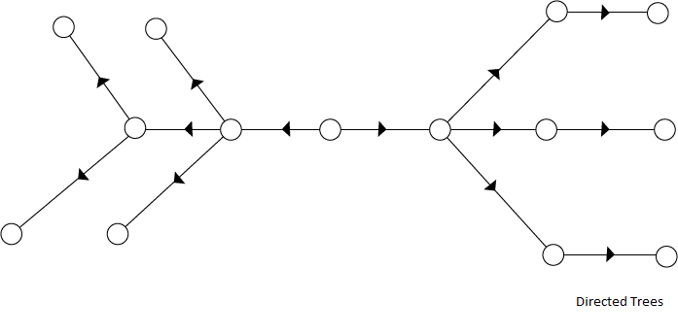
Fig 1

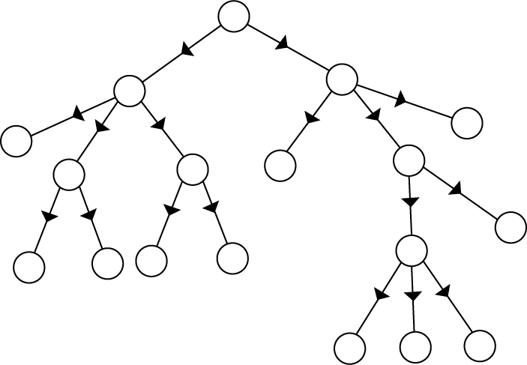
Fig 2
The node which has out degree 0 is called an external node or a terminal node or a leaf. The nodes which have out degree greater than or equal to one are called internal node.
1.5.2 Ordered tree: If in a tree at each level, an ordering is defined, then such a tree is called an ordered tree.
Example: The trees shown in the figure 3 and 4 below represent the same tree but have different orders.
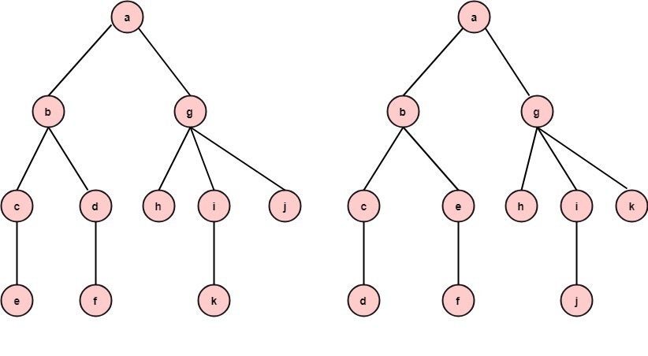
Fig 3 Fig 4
1.5.3 Rooted tree: If a directed tree has exactly one node or vertex called root whose incoming degrees is 0 and all other vertices have incoming degree one, then the tree is called rooted tree. See fig 5 below:

Note: 1. A tree with no nodes is a rooted tree (the empty tree)
2. A single node with no children is a rooted tree.

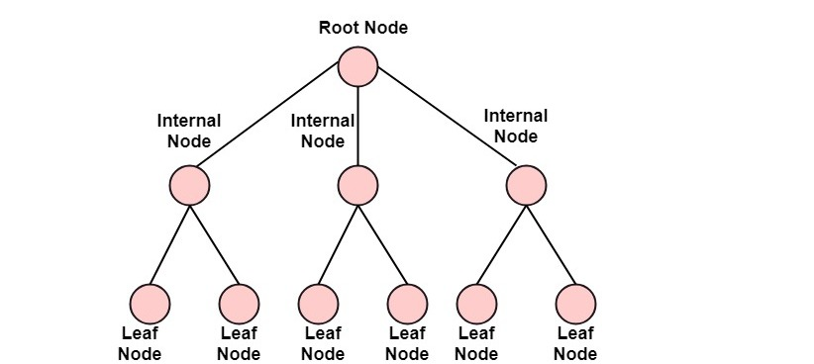Fig 5
1.5.4 Forest:
If the root and corresponding edges connecting the nodes are deleted from a tree, we obtain a set of disjoint trees. This set of disjoint trees is called a forest.
1.5.5 Binary tree: In a normal tree, every node can have any number of children. A binary tree is a special type of tree data structure in which every node can have a maximum of 2 children. One is known as a left child and the other is known as right child.
OR
A tree in which every node can have a maximum of two children is called binary tree.
In a binary tree, every node can have either 0 children or 1 child or 2 children but not more than 2 children. The below fig 6 is an example of binary tree
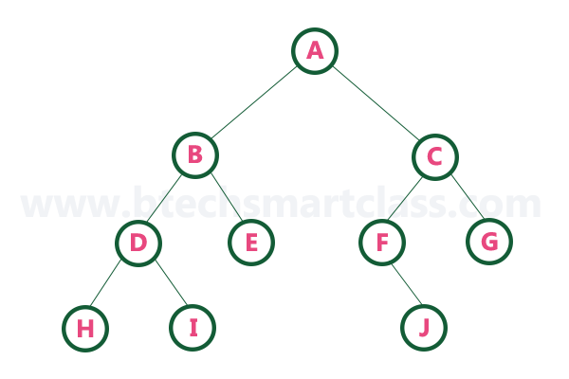Fig 6

a) Binary Expression Trees:
An algebraic expression can be conveniently expressed by its expression tree. An expression having binary operators can be decomposed into
<left operand or expression> (operator) <right operand or expression>. Depending upon precedence of evaluation. The expression tree is a binary tree whose root contains the operator and whose left sub tree contains the left expression, and right sub tree contains the right expression.
Example: Construct the binary expression tree for the expression (a+ b)*(d/c)
Solution: The binary expression tree for the expression (a+ b)*(d/c) is shown in fig 7
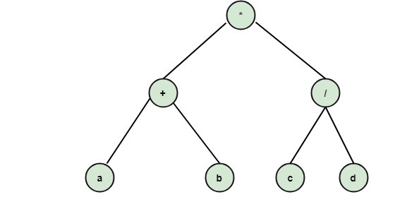
Fig 7

b) Complete Binary Tree:
In a binary tree, every node can have a maximum of two children. But in strictly binary tree, every node should have exactly two children or none and in complete binary tree all the nodes must have exactly two children and at every level of complete binary tree there must be 2^{level} number of nodes. For example at level 2 there must be 2² = 4 nodes and at level 3 there must be 2³ =8 nodes.
OR
Complete binary tree is a binary tree if it is all levels, except possibly the last, have the maximum number of possible nodes as for left as possible. The depth of the complete binary tree having n nodes is log₂ n+1.
Example: The tree shown in below fig 8 is a complete binary tree:
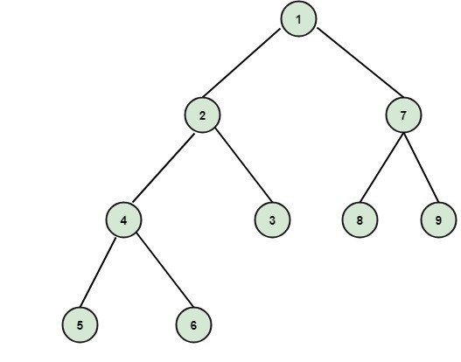Fig 8
c) Full Binary Tree: Full binary tree is a binary tree in which all the leaves are on the same level and every non-leaf node has two children. Fig 8 is an example of full binary tree:
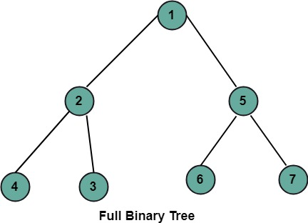 Fig 8
1.6 Properties of tree
- There is only one path between each pair of vertices of a tree.
- If a graph G there is one and only one path between each pair of vertices G is a tree.
- A tree T with n vertices has n-1 edges.
- A graph is a tree if and only if it a minimal connected.
- Every tree which has at least two vertices should have at least two leaves.
- Trees have many characteristics as:
Let T be a graph with n vertices, then the following statements are equivalent:
  - T is a tree.
  - T is connected graph, and every edge is a cut-edge.
  - T contains no cycles, and for any new edge e, the graph T+ e has exactly one cycle.
- Every edge of a tree is cut -edge.
- Adding one edge to a tree defines exactly one cycle.
- Every connected graph contains a spanning tree.
- Every tree has at least two vertices of degree two.
Summary
The points discussed in this lecture are summarized below:
- The different types of trees like directed tree, ordered tree, rooted tree, binary tree have been discussed.
- If in a tree at each level, an ordering is defined, then such a tree is called an ordered tree.
- An acyclic directed graph having one node with in degree 0, while all other nodes having in degree 1, is called directed tree.
- A rooted tree is a directed tree that has exactly one node or vertex called root whose in degree is 0 and all other vertices have incoming degree one
- A tree in which every node can have a maximum of two children is called binary tree.
Frequently asked questions
Q1 How does a binary tree work?
ANS A binary tree is made of nodes, where each node contains a "left" pointer, a "right" pointer, and a data element. The "root" pointer points to the topmost node in the tree. The left and right pointers recursively point to smaller "sub trees" on either side.

Q2 Is Binary Tree directed or undirected?
ANS A tree is an undirected graph. Unless qualified otherwise, trees in Mathematics or Graph Theory are usually assumed to be undirected, but in Computer Science or Programming or Data Structure, trees are usually assumed to be directed and rooted.

REFERENCES

WEB LINKS

1http://www.btechsmartclass.com/data_structures/tree-terminology.html

2 https://www.slideshare.net/AdilAslam4/chapter-11-tree-in-discrete-mathematics

VIDEO LINKS
1https://youtu.be/Fb62cCPnuY0

2 https://youtu.be/GgL1yzASrXo

APPLICATIONS
Binary Search Tree - Used in many search applications where data is constantly entering/leaving, such as the map and set objects in many languages' libraries. Binary Space Partition - Used in almost every 3D video game to determine what objects need to be rendered.
PRACTICE QUESTIONS
Q1 Draw two different binary trees with five nodes having maximum number of leaves.
Q2. Draw two different binary trees with five nodes having only one leaf.

